**Modules**

* Phase Space Reconstruction
* Sliding-window method
* Least Squares Support Vector Regression

Phase Space Reconstruction

In time series prediction, the time series are typically expanded into three or higherdimensional space to exploit the information that is implicit in them. Selecting a suitable pairing of embedding dimension m (lag) and time delay τ is very important for phase space reconstruction.

Consider a time series x={x1,x2,x3…xn}.The time-delay vectors can be reconstructed as follows, where X is the input matrix and Y is the corresponding output matrix. The output of the analysis is fed back to the input and future values are predicted from previous values in the time series.

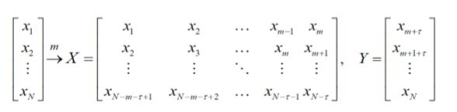

Sliding-window method

As suggest in [1], the learning dataset used in this study was collected within a slidingwindow. Fig. 1 depicts the sliding-window and phase space construction. Since the forecast is one step ahead (hence the term, “one-step ahead forecasting”), the forecast horizon is 1. In the first validation, the working window includes p historical observations (𝑥1,𝑥2,𝑥3, …𝑥𝑝) which are used to forecast the next value 𝑥𝑝+1. In the second validation, the oldest value 𝑥1 is removed from the window and the latest value𝑥𝑝+1 is added, keeping the length of the sliding window constant at p. The next forecast value will be 𝑥𝑝+2. The window continues to slide until the end of the dataset is reached. If the number of observations is N, then the total number of validations is (N-p).

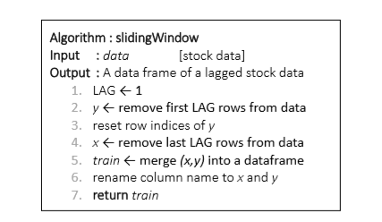

Least Squares Support Vector Regression

The LSSVR approach proposed by Suykens et al. (2002) [8] is a well-developed ML technique with many advanced features that support a high generalization capacity and fast computation. The LSSVR training process entails the use of a least squares cost function to obtain a linear set of equations in a dual space to minimize the computational cost. Accordingly, iterative methods, such as the conjugate gradient method are typically used to derive a solution by efficiently solving a set of linear equations. To reduce the computational burden of the LSSVR for function estimation, the regression model in this study uses a quadratic loss function.

The least squares version of the SVM classifier is obtained by reformulating the minimization problem as:

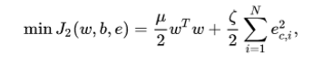

For the kernel function K(𝑥,𝑥𝑖) one typically has the Radial Basis Function:

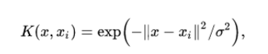

The LSSVR involves equality instead of inequality constraints and works with a least squares objective function. The LSSVR approach considerably reduces computational complexity and increases efficiency compared to standard SVM. LSSVR solves linear equations instead of a quadratic programming problem.